**Minutes of Meeting held on October 20, 2022**

**Agenda: Services and Solutions Streamlined (S3) App, Version 1.0 Release**

Above mentioned App with 8 modules has been released by the Team Nortcele Systems in presence of Patron Capt. RPS Tulsi, Azea Botanica, as per following details.

1. **Onboarding Screen** has been delivered including 3 screens.

Enhancement required: Introductory text content required.

Team Azea Botanica will provide the text content.

1. **Login**
2. Enhancement required: After Logout, an additional screen required. This screen will have the information “You are Successfully Logout” with the button / link that will navigate to again login screen.
3. Terms and Condition to use the app shall be provided by the Team Azea Botanica.
4. **Profile** has been delivered including following features
   1. Profile contact edit
   2. Create profile (in progress)
   3. Manage House Hold
      1. Share personal details (in progress)
      2. Add family member (in progress)
      3. Add Daily Help (in progress)
      4. Add Vehicle (in progress)
      5. Add Pets (in progress)
   4. Add Flat/Villa (in progress)
5. **Notification**

Enhancement Required: Read/Unread feature shall be implemented.

1. **Invoice (Monthly and Service Request)**
2. Minor Layout changes in Invoice format has suggested by the Team Azea.
3. The Invoice Generation module prototypes has approved by the team Azea.
4. **Helpdesk**
5. Helpdesk Module shall also be implemented into mobile app version.
6. Complaint Log Sheet format has provided by the Team Azea. This sheet is to be implemented into helpdesk account. On receiving complaint, Admin/Helpdesk will print the complaints log sheet and hand over to the technician. This sheet will have the complaint number, date, flat number (unit number), name of resident, Description, category. Technician will attend the complaint and after resolving complaint, resident will pay the required bill amount and mention the transaction ID on the complaint log sheet. The sheet format is as following:

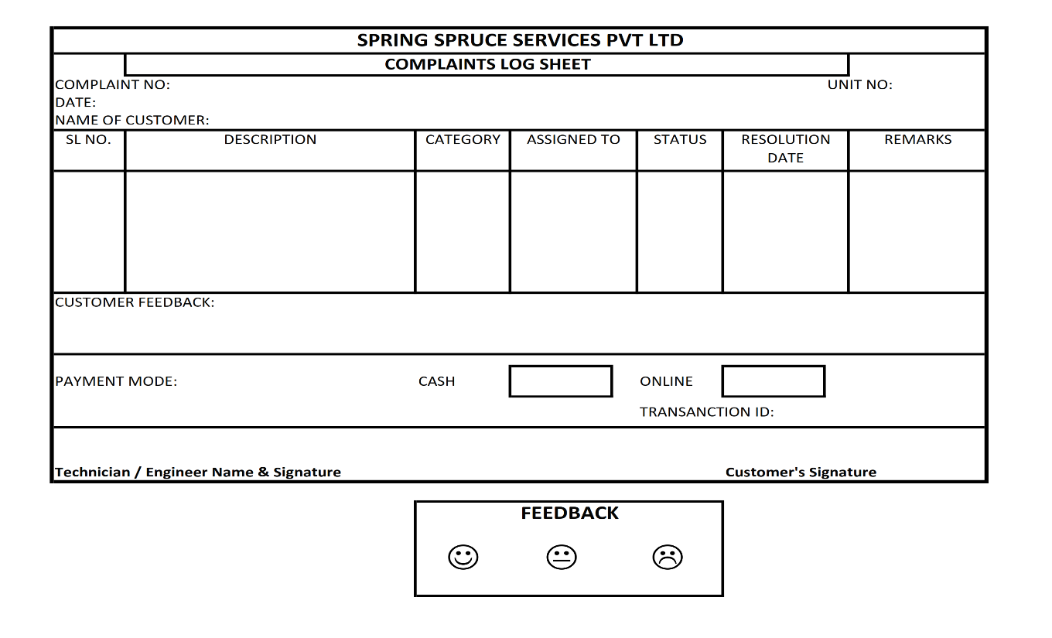

1. **Visitor Management (Resident)**
2. **Visitor Management (Security)** shall also be implemented into mobile app version.

Apart from that Team Azea suggested following actions to be taken to move forward:

1. Admin Account, web version shall be created for tracking/Managing accounts related transactions.
2. QR code payment link of Team Azea, shall be given on helpdesk module, so that resident can make payment by following that link, Team Azea shall track the payment related transaction manually.

***Prepared by:***

***Team Nortcele Systems Pvt. Ltd.***